GCSE Design and Technology  - Product Design Topic Checklist |  |  | Name: Class:
 |  |  | Teacher:
Section A | Core Technical Principles |  | Page no.  Blue | Page no.  White | 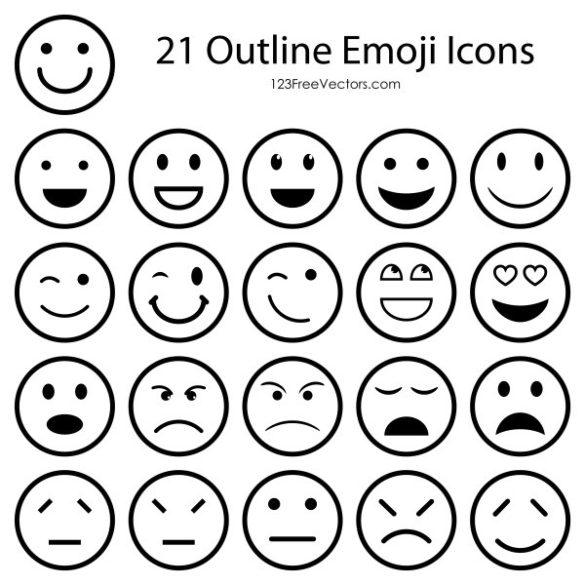
New and emerging technologies | Technology in Manufacture, CAD/CAM, Product Sustainability, Products in society, Social issues |  | 1-10 | 4-12
Energy generation and storage | Powering Systems |  | 12-13 | 13-14
Developments in new materials | Modern, smart and composite materials and technical textiles. |  | 32-33 | 30-31
Systems approach to designing | Electronic systems-circuits, inputs, processes and outputs. |  | 24-27 | 24-26
Mechanical devices | Mechanisms, gears, cams & followers, pulleys& belts, levers & Linkages |  | 28-31 | 27-29
Materials and their working properties | Material Properties, Papers & boards, Natural timbers, Manufactured boards, Metals & alloys, Polymers[plastics], Textiles. |  | 14-23 | 15-23
Materials and their working properties | Sources of materials/Production of materials- papers & boards, woods, metals, plastics, textiles. |  | 44-47 | 42-45
Materials and their working properties | Production Aids-jigs, patterns and templates |  | 42-43 | 40-41
Section B | Specialist Technical Principles |  | Page no.  Blue | Page no.  White
Selection of materials or components | Functionality, availability, aesthetics and cost. Environmental, social, cultural and ethical factors |  | 34--35 | 32-33
Forces and stresses | Tension, compression, shear, torsion, bending.  Enhancing materials-Reinforcing, stiffening and making materials more flexible |  | 36-37 | 34-35
Ecological and social Footprint | Product sustainability, The 6 R’s, social footprint |  | 6-9 | 7-10
Scales of Production | One-off. Batch. Mass and continuous production |  | 38-39 | 36
Woods, Metals and Polymers | Sources and properties of materials |  | 44-47, 58-59 | 55-56
Woods, Metals and Polymers | Stock forms |  | 60 | 57
Woods, Metals and Polymers | Standard components- screws, nuts & bolts, rivets, hinges, knock down fittings |  | 60-63 | 57-59
Woods, Metals and Polymers | Shaping and forming with different tools |  | 64-69 | 60-64
Woods, Metals and Polymers | Moulding and joining materials |  | 70-71 | 65-67
Woods, Metals and Polymers | Treatments and finishes |  | 72-73 | 68-69
Woods, Metals and Polymers | Quality control-printing marks and tolerances |  | 40-41 | 38-39
Section C | Designing and Making Principles |  | Page no.  Blue | Page no.  White
Designing Principles | The work of others- designers and companies |  | 94-95 | 89
Designing Principles | Design briefs, Investigation and research- including ergonomics |  | 96-103 | 90-97
Designing Principles | Design strategies |  | 104-105 | 98
Designing Principles | Exploring and developing design ideas- including drawing techniques [communicating ideas in isometric projection, one point and two-point perspective, orthographic projection, exploded views and systems/schematic diagrams] |  | 106-111 | 99-104
Making Principles | Manufacturing Specifications |  | 112-113 | 105-106
Making Principles | Developing prototypes and modelling -virtual modelling/modelling in card, foam, clay or other suitable materials] |  | 114-115 | 107-108
Making Principles | Material management-Marking out and using materials efficiently |  | 116-117 | 109-110
Making Principles | Health and safety-working safely |  | 118-119 | 111
Use the space below to show which revision methods you have used to revise different topics
Flash cards
Revision Roulette
Blockbusters
Clock revision/revision wheel
Cops and Robbers
Battleships
Brain dump
Mind map
Self-test quiz

Past papers

Others…

